kur4t0rrri
1voI
USAGE REPORTS - RRI SIARAN LUAR NEGERI LEMBAGA PENYIARAN PUBLIK RADIO REPUBLIK INDONESIA from 202…
PERIOD : 2024-01-01 12:00 to 2024-01-31 12:00

ADDRESS : JL. MERDEKA BARAT, 4-5, 4TH FLOOR, JAKARTA 10110

CID -
: - , 4575612400083394 - DIA MIX 100M

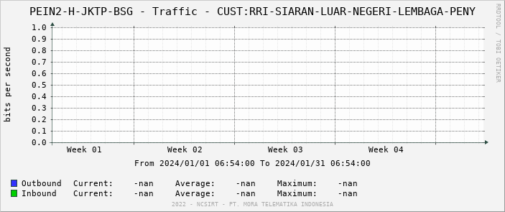

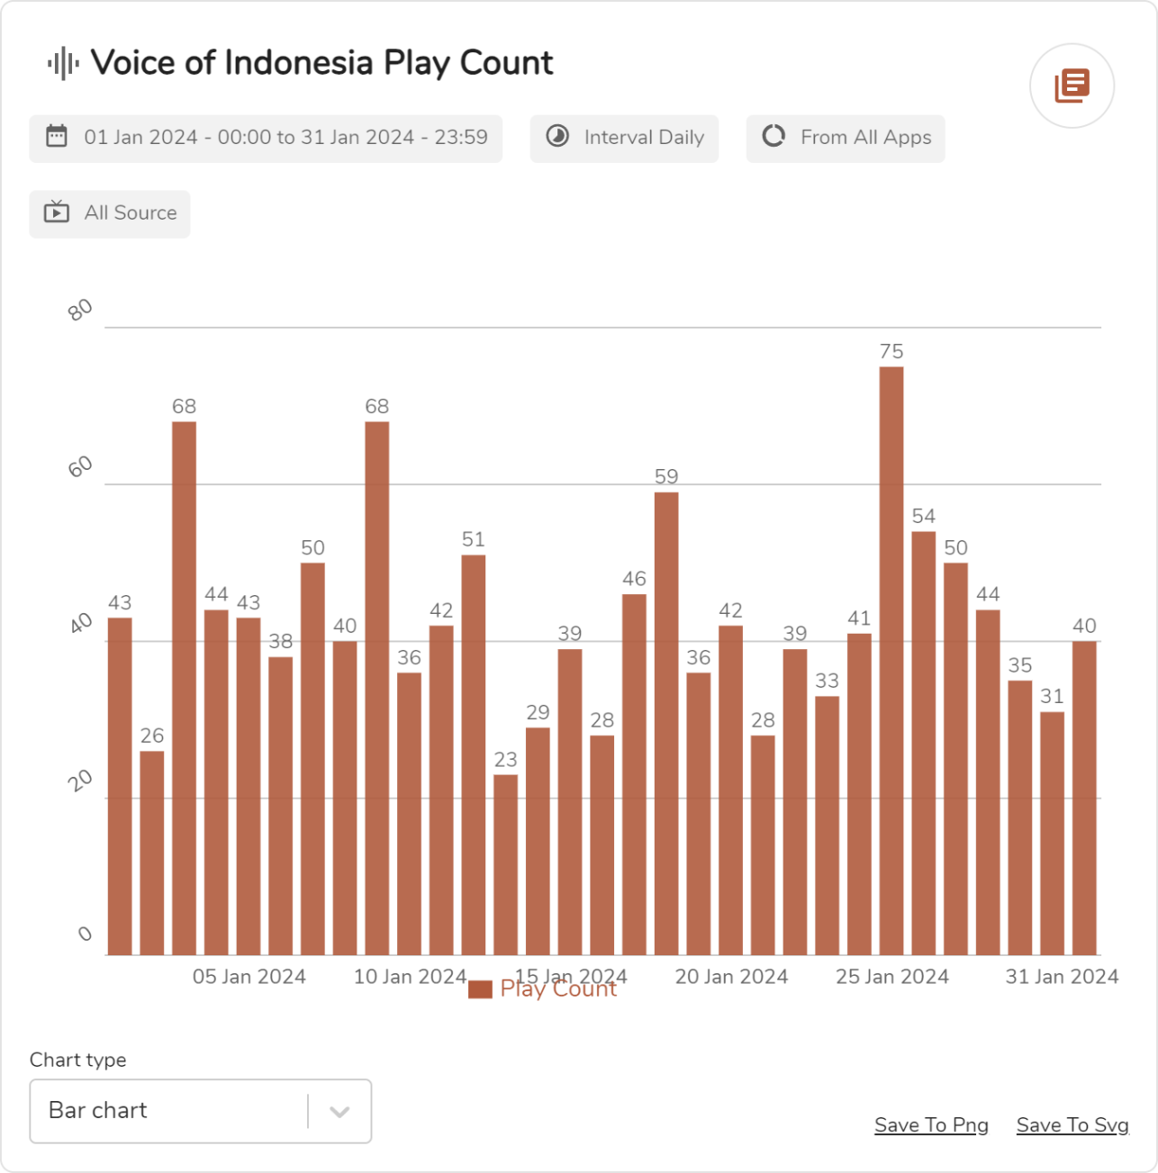

1/1

